**IP security (IPSec)**

The **IP security (IPSec)** is an Internet Engineering Task Force (IETF) standard suite of protocols between 2 communication points across the IP network that provide data authentication, integrity, and confidentiality. It also defines the encrypted, decrypted and authenticated packets. The protocols needed for secure key exchange and key management are defined in it.

**Uses of IP Security –**  
IPsec can be used to do the following things:

* To encrypt application layer data.
* To provide security for routers sending routing data across the public internet.
* To provide authentication without encryption, like to authenticate that the data originates from a known sender.
* To protect network data by setting up circuits using IPsec tunneling in which all data is being sent between the two endpoints is encrypted, as with a Virtual Private Network(VPN) connection.

**Components of IP Security –**  
It has the following components:

1. **Encapsulating Security Payload (ESP) –**  
   It provides data integrity, encryption, authentication and anti replay. It also provides authentication for payload.
2. **Authentication Header (AH) –**  
   It also provides data integrity, authentication and anti replay and it does not provide encryption. The anti replay protection, protects against unauthorized transmission of packets. It does not protect data’s confidentiality.

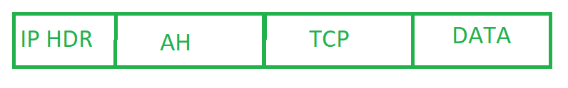

1. **Internet Key Exchange (IKE) –**  
   It is a network security protocol designed to dynamically exchange encryption keys and find a way over Security Association (SA) between 2 devices. The Security Association (SA) establishes shared security attributes between 2 network entities to support secure communication. The Key Management Protocol (ISAKMP) and Internet Security Association which provides a framework for authentication and key exchange. ISAKMP tells how the set up of the Security Associations (SAs) and how direct connections between two hosts that are using IPsec.

Internet Key Exchange (IKE) provides message content protection and also an open frame for implementing standard algorithms such as SHA and MD5. The algorithm’s IP sec users produces a unique identifier for each packet. This identifier then allows a device to determine whether a packet has been correct or not. Packets which are not authorized are discarded and not given to receiver.

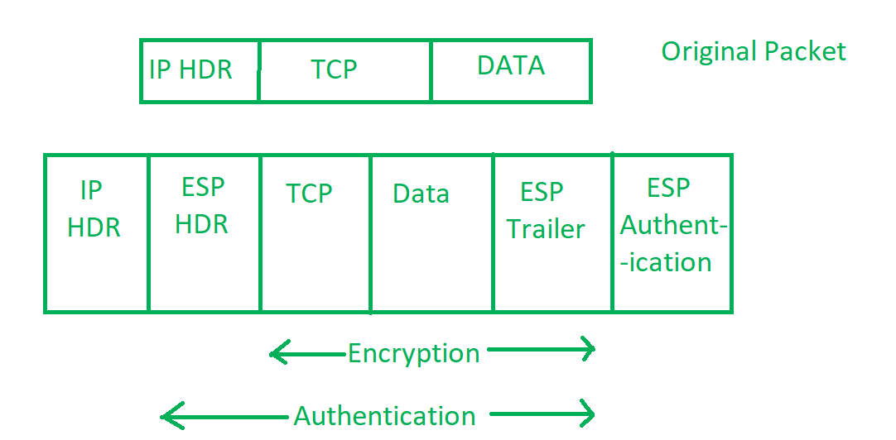

**Working of IP Security –**

1. The host checks if the packet should be transmitted using IPsec or not. These packet traffic triggers the security policy for themselves. This is done when the system sending the packet apply an appropriate encryption. The incoming packets are also checked by the host that they are encrypted properly or not.
2. Then the **IKE Phase 1** starts in which the 2 hosts( using IPsec ) authenticate themselves to each other to start a secure channel. It has 2 modes. The **Main mode** which provides the greater security and the **Aggressive mode** which enables the host to establish an IPsec circuit more quickly.
3. The channel created in the last step is then used to securely negotiate the way the IP circuit will encrypt data across the IP circuit.
4. Now, the **IKE Phase 2** is conducted over the secure channel in which the two hosts negotiate the type of cryptographic algorithms to use on the session and agreeing on secret keying material to be used with those algorithms.
5. Then the data is exchanged across the newly created IPsec encrypted tunnel. These packets are encrypted and decrypted by the hosts using IPsec SAs.
6. When the communication between the hosts is completed or the session times out then the IPsec tunnel is terminated by discarding the keys by both the hosts.

**Transport Layer Security (TLS)**

Transport Layer Securities (TLS) are designed to provide security at the transport layer. TLS was derived from a security protocol called [Secure Socket Layer (SSL)](https://www.geeksforgeeks.org/secure-socket-layer-ssl/). TLS ensures that no third party may eavesdrop or tampers with any message.

There are several benefits of TLS: 

* **Encryption:**   
  TLS/SSL can help to secure transmitted data using encryption.
* **Interoperability:**   
  TLS/SSL works with most web browsers, including Microsoft Internet Explorer and on most operating systems and web servers.
* **Algorithm flexibility:**   
  TLS/SSL provides operations for authentication mechanism, encryption algorithms and hashing algorithm that are used during the secure session.
* **Ease of Deployment:**   
  Many applications TLS/SSL temporarily on a windows server 2003 operating systems.
* **Ease of Use:**   
  Because we implement TLS/SSL beneath the application layer, most of its operations are completely invisible to client.

**Working of TLS:**   
The client connect to server (using [TCP](https://www.geeksforgeeks.org/tcp-ip-model/)), the client will be something. The client sends number of specification:

1. Version of SSL/TLS.
2. which cipher suites, compression method it wants to use.

The server checks what the highest SSL/TLS version is that is supported by them both, picks a cipher suite from one of the clients option (if it supports one) and optionally picks a compression method. After this the basic setup is done, the server provides its certificate. This certificate must be trusted either by the client itself or a party that the client trusts. Having verified the certificate and being certain this server really is who he claims to be (and not a man in the middle), a key is exchanged. This can be a public key, “PreMasterSecret” or simply nothing depending upon cipher suite.

Both the server and client can now compute the key for symmetric encryption. The handshake is finished and the two hosts can communicate securely. To close a connection by finishing. TCP connection both sides will know the connection was improperly terminated. The connection cannot be compromised by this through, merely interrupted.